Software Engineering II Final Project Proposal – 3/8/17

**Team Members:** Yuri Khechoyan & Vikram Hegde

**Project Title:** Customer Queue

**Business Requirements:**

* Create a Customer Queue platform that helps identify who has not been assisted yet.
* Maintain order in which helps the business handle their customers’ requests and wait times more efficiently; know who is next in line to be assisted.
* Explain how program will benefit their employees & customers.

**Use Cases:**

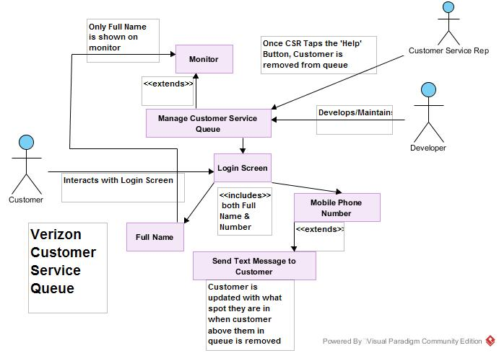

|  |  |
| --- | --- |
| **UC1 Manage Customer Service Queue** | |
| **Scope** | Business |
| **Level** | Sea |
| **Goal in Context** | Allows the Developer to access/modify various Customer Service Queue functions. |
| **Primary Actor** | Owner/Developer |
| **Stakeholders** | Developer, Customers & Customer Service Representatives |
| **Preconditions** | Run Customer Service Queue software |
| **Triggers** | Program is launched at the beginning of the work day |
| **Success Guarantee** | The Customer Service Queue waits for user input |
| **Main Success Scenario:** | |
| Customer Service Queue: There are 2 options to choose from:  1. Enter Full Name  2. Enter Mobile Phone Number | |
| **Extensions:** | |
| None | |

|  |  |
| --- | --- |
| **UC2 Enter Full Name** | |
| **Scope** | System |
| **Level** | Sea Level |
| **Goal in Context** | Present a form to the user to enter their Full Name Credential in order to move forward |
| **Primary Actor** | Customer |
| **Stakeholders** | Developer, Customer, Customer Service Representative |
| **Preconditions** | Program must be at the login screen |
| **Triggers** | Customer taps on the text field to enter their name. Virtual keyboard is initiated |
| **Success Guarantee** | Customer taps on the "Done" button to enter their name and move on to the next part |
| **Main Success Scenario:** | |
| 1. Customer: taps on the Full Name text field.  2. Customer Queue: Initiates a virtual on-screen keyboard for the customer to enter their Full Name  3. Customer taps on the "Done" button when they are finished typing in the name and want to move on to the next part. | |
| **Extensions:** | |
| **3a**: If there is no name in the field or if the Customer provided the first name only, the program will throw a message alert box asking them to include all required information. Same thing happens if they only enter their last name. | |

|  |  |
| --- | --- |
| **UC3 Enter Mobile Phone Number** | |
| **Scope** | System |
| **Level** | Sea Level |
| **Goal in Context** | Present a form for the customer to enter their phone number |
| **Primary Actor** | Customer |
| **Stakeholders** | Developer, Customer & Employee |
| **Preconditions** | Program must be at the login screen |
| **Triggers** | Customer taps on the text field to enter their number. Virtual keypad is initiated |
| **Success Guarantee** | Customer taps on the "Done" button to enter their name and move on to the next part |
| **Main Success Scenario:** | |
| 1. Customer: taps on the Mobile Number text field.  2. Customer Service Queue: Initiates a virtual on-screen keypad for the customer to enter their Mobile Number  3. Customer taps on the "Done" button when they are finished typing in their number and want to move on to the next task. | |
| **Extensions:** | |
| **3a.** If there is no number in the field, if the Customer did not provide the full 10-digit number, or Customer has entered a fake '555' number, the program will throw a message alert box asking them to include all required information. | |

|  |  |
| --- | --- |
| **UC4 Submit Button** | |
| **Scope** | System |
| **Level** | Sea Level |
| **Goal in Context** | Once all required credentials are met, customer can submit this information into the queue. |
| **Primary Actor** | Customer |
| **Stakeholders** | Developer, Customer & Employees |
| **Preconditions** | The Customer must enter all of the required credentials in order for the submission to be processed |
| **Triggers** | Customer must tap the "Submit" button after all field are filled in |
| **Success Guarantee** | A message alert pops up to say "Thank You for Registering" and then the program goes back to the login screen. Customer that just registered receives a text message **"You are now X in line. Thank You for being patient with us!"** |
| **Main Success Scenario:** | |
| 1. Customer: Receives a text confirmation | |
| **Extensions:** | |
| **1a.** In order for this information to be submitted, the Customer must tap on the "Submit" button. | |

|  |  |
| --- | --- |
| **UC5 Removal from Queue** | |
| **Scope** | System |
| **Level** | Sea Level |
| **Goal in Context** | Allows the Employee to remove customers from the list. |
| **Primary Actor** | Employee |
| **Stakeholders** | Developer, Customer & Customer Service Representative |
| **Preconditions** | Customers have already added themselves to the queue and are awaiting assistance |
| **Triggers** | Employee taps on the 'Delete' button |
| **Success Guarantee** | Customer at the top of the list is removed from the queue. Customer that was first in line receives this text: **"You are 1st in line, please wait for your name to be called. Thank You."**  Also, all other customers receive this text message simultaneously **"You are now X-1 in line. Thank You for being patient with us!"** The 'X-1' is substituted with the spot that they hold in the queue. |
| **Main Success Scenario:** | |
| 1. Customer: (if 1st in the queue) is removed from the queue on the monitor in the store. If not 1st, they are automatically moved up 1 spot | |
| **Extensions:** | |
| **1a.** Customer that was removed receives: **"You are 1st in line, please wait for your name to be called. Thank You."**  **2a.** Customer that was not 1st in the queue receives: **"You are now X-1 in line. Thank you for being patient with us!"** | |

**High Level Design:**

